Day 34 - ADF (Azure Data Factory)

- Cloud based ETL/ELT service used to collect, transform, and move data from different sources to destinations.
- It’s like a data pipeline builder that automates the process of data integration between systems.

- Create blob storage and container.
- Create database and table using query editor.

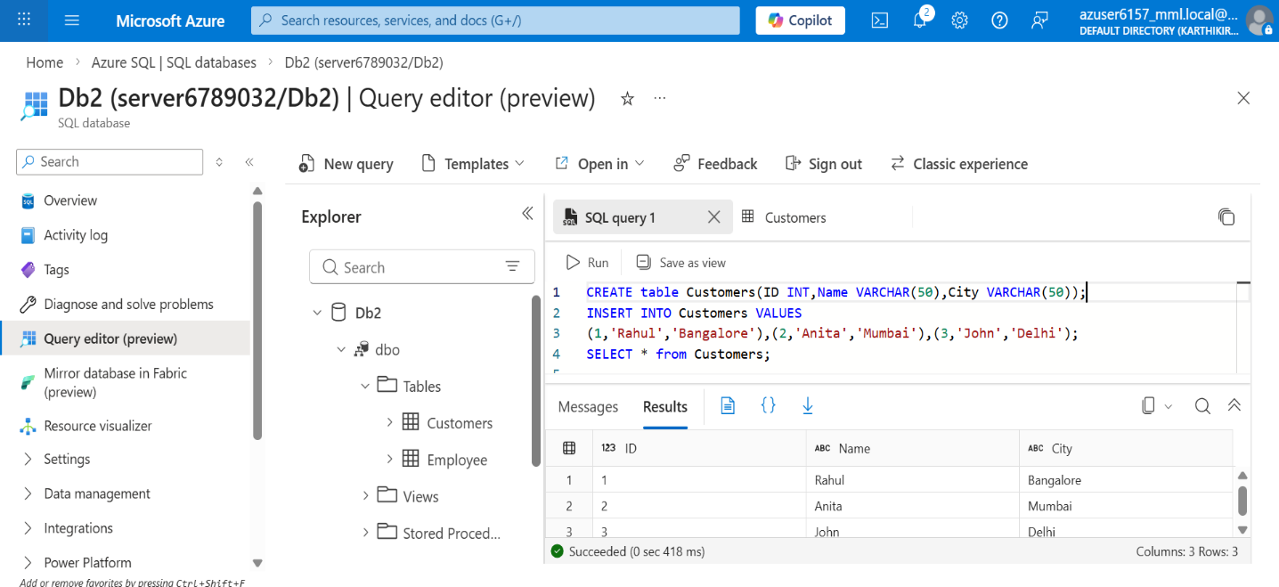

- Open data factory and create new data factory

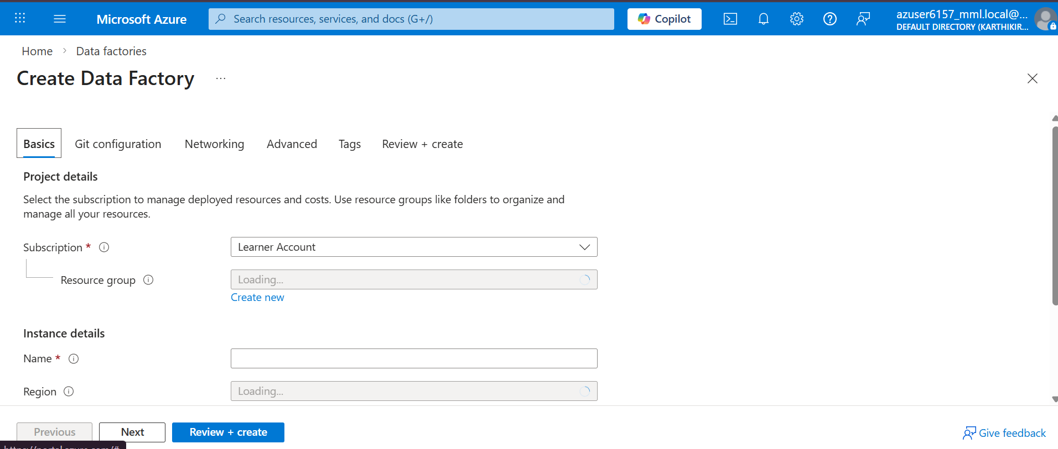
- Launch Azure Data Factory studio
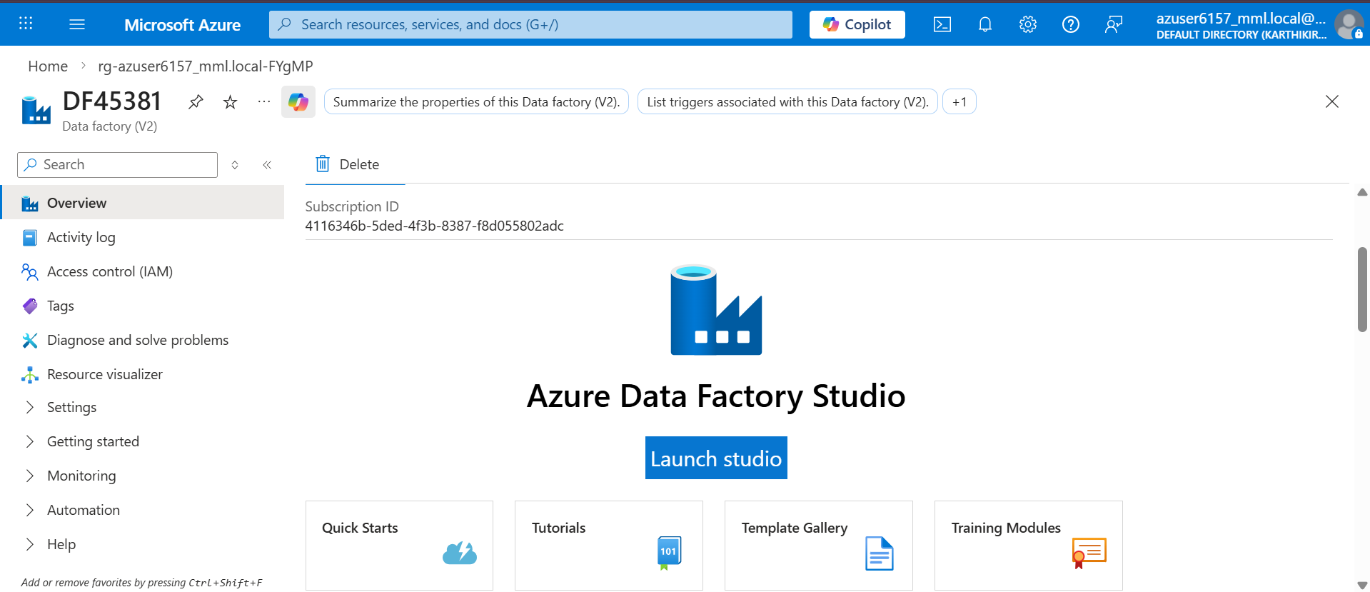

- Link Services
- Manage->linked services->new
- Link SQL database service
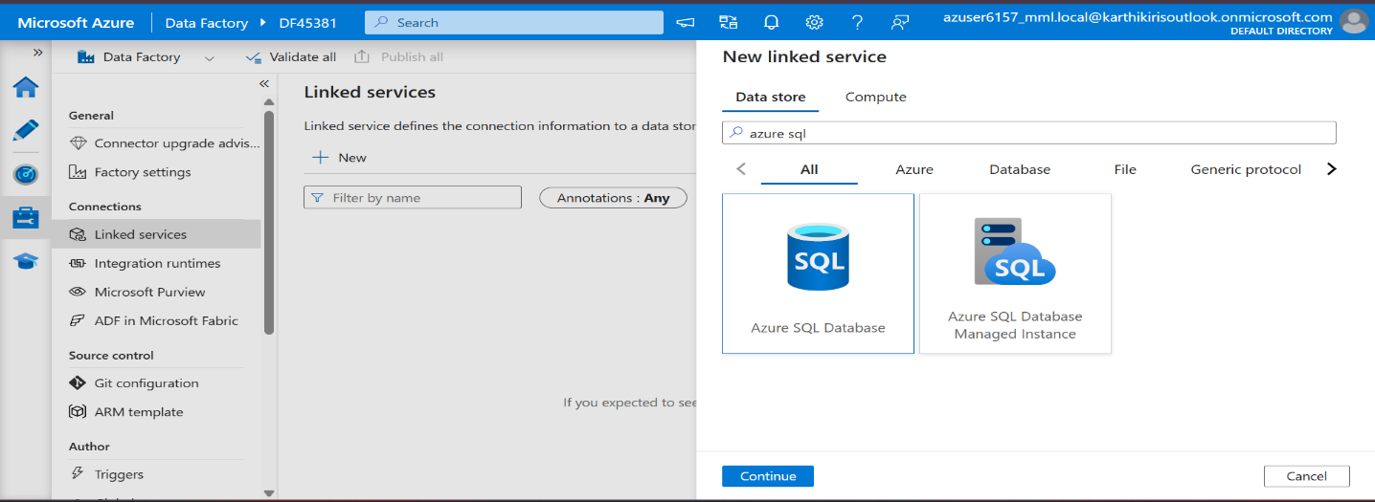

- Link blob storage service
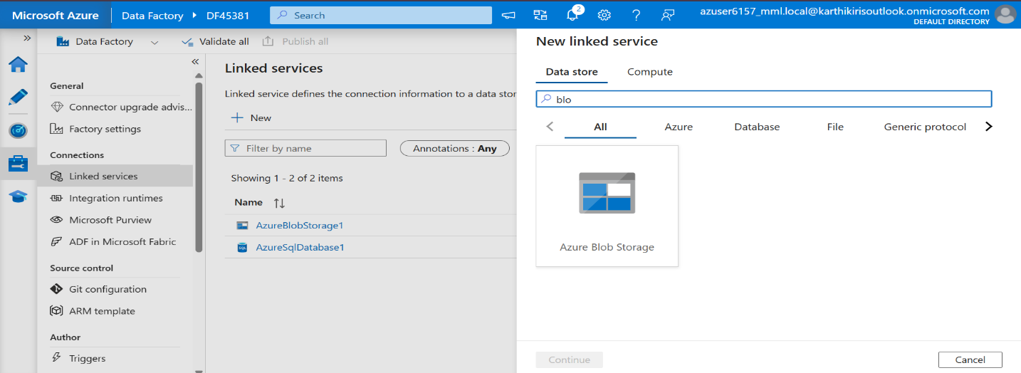
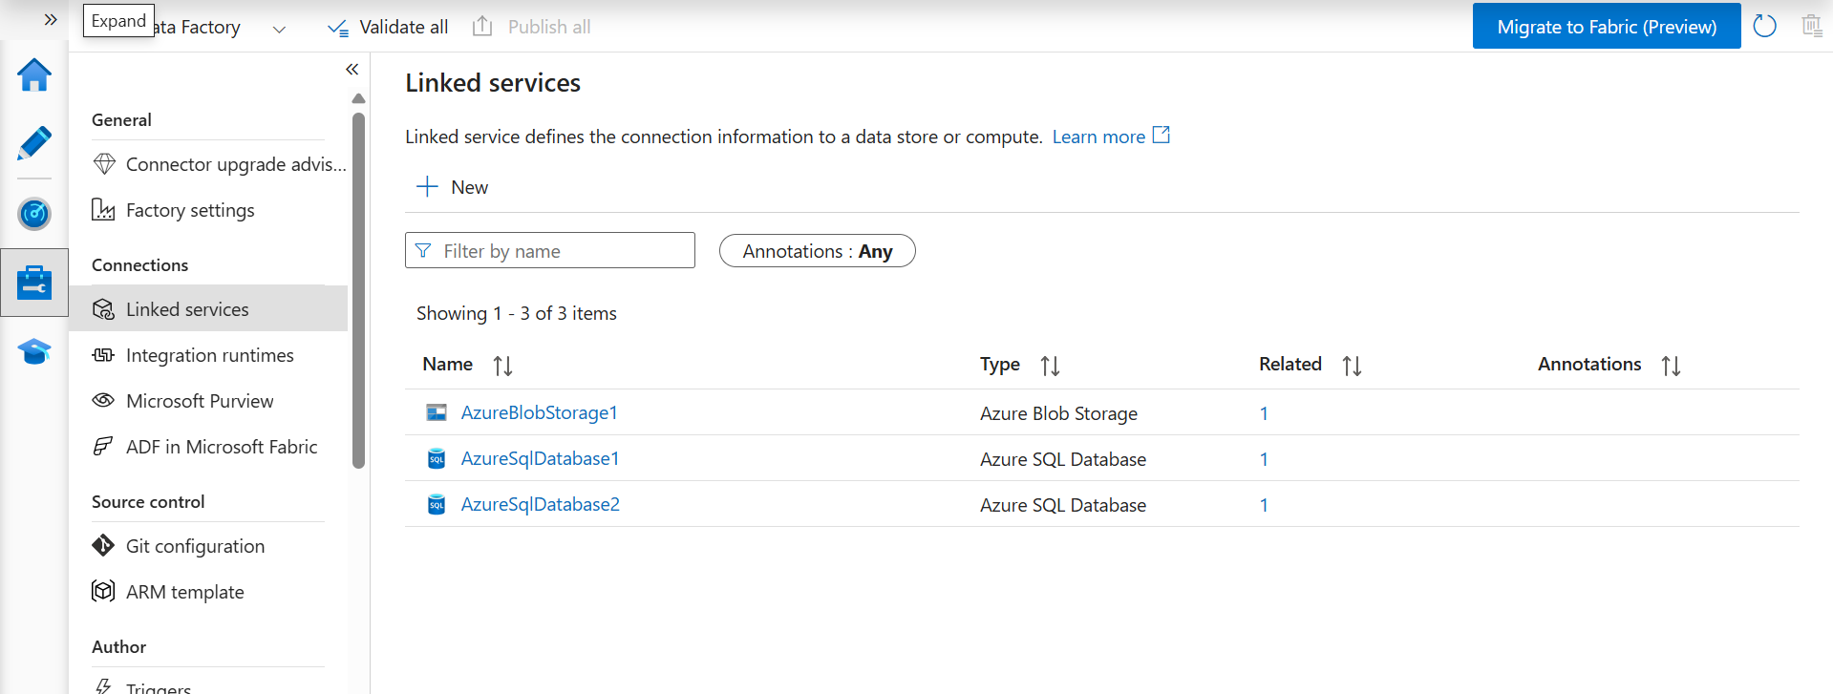

- Create Pipeline
- Author->datasets->new dataset
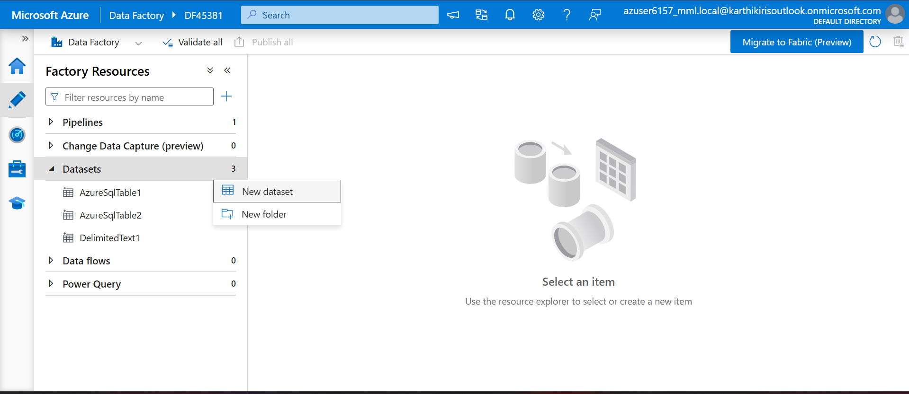
- Bob storage
- Select container folder in filename ,give a filename with .csv extension

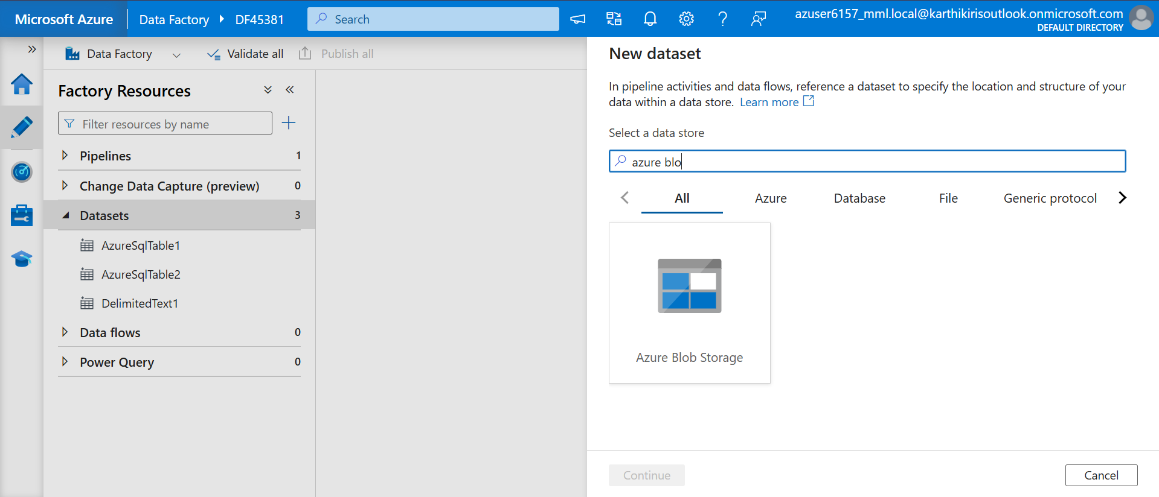
- SQL Database
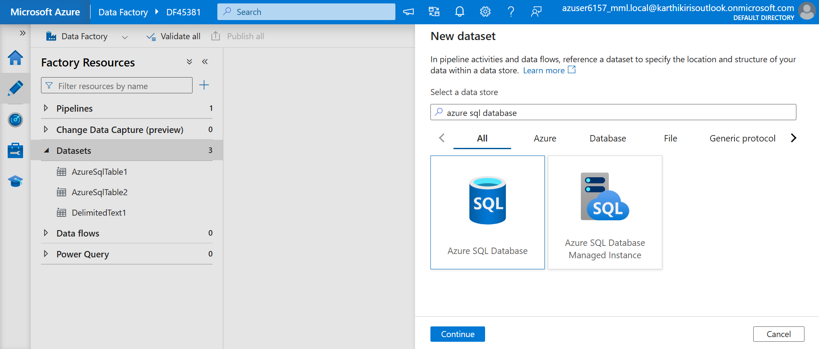

- Then choose pipeline
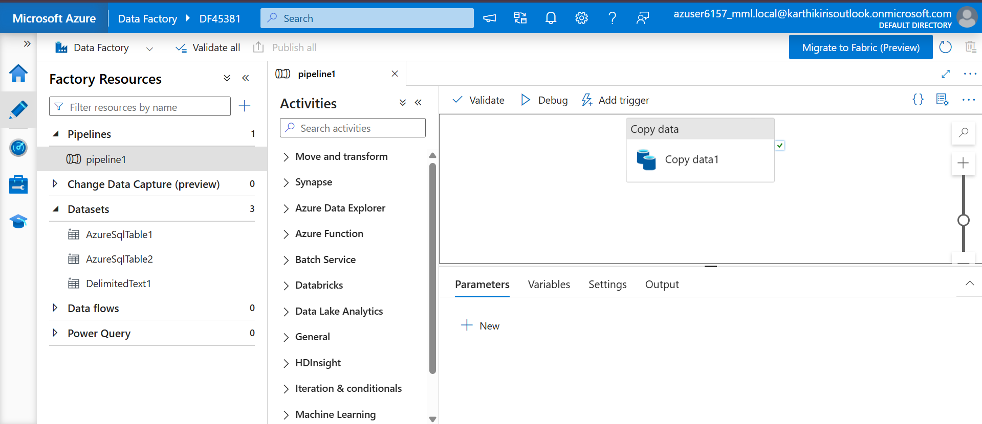
- Drag copy activity
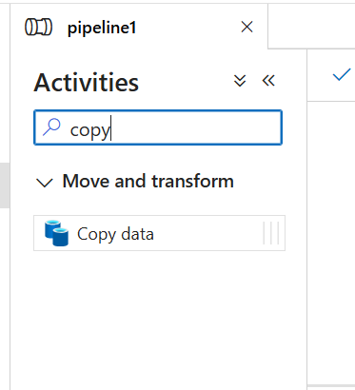

- Set sql database linked service as source

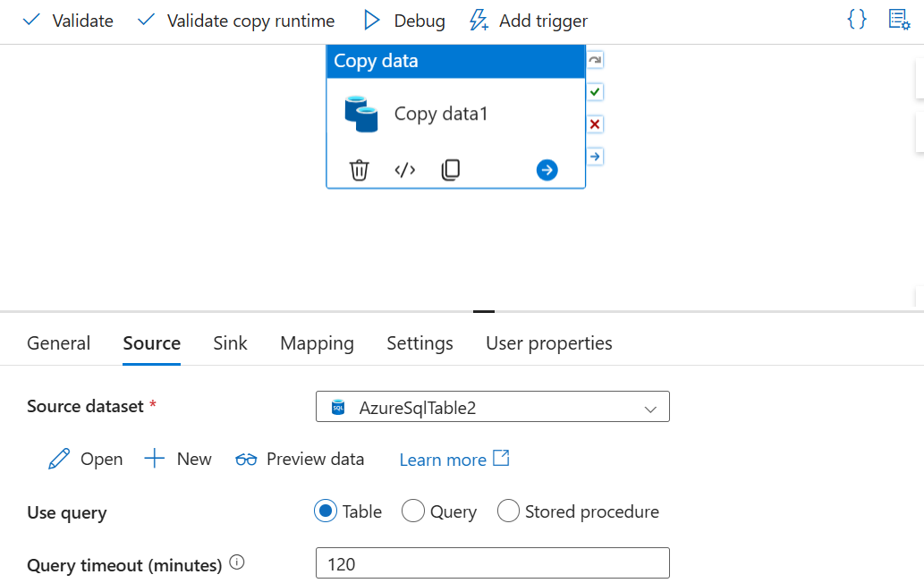

- Set storage service as sink
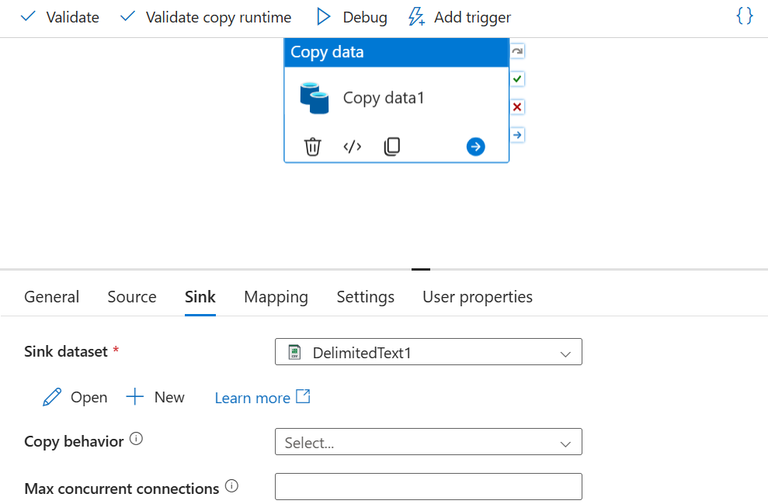
- Then validate, publish and trigger(add trigger ->trigger now).
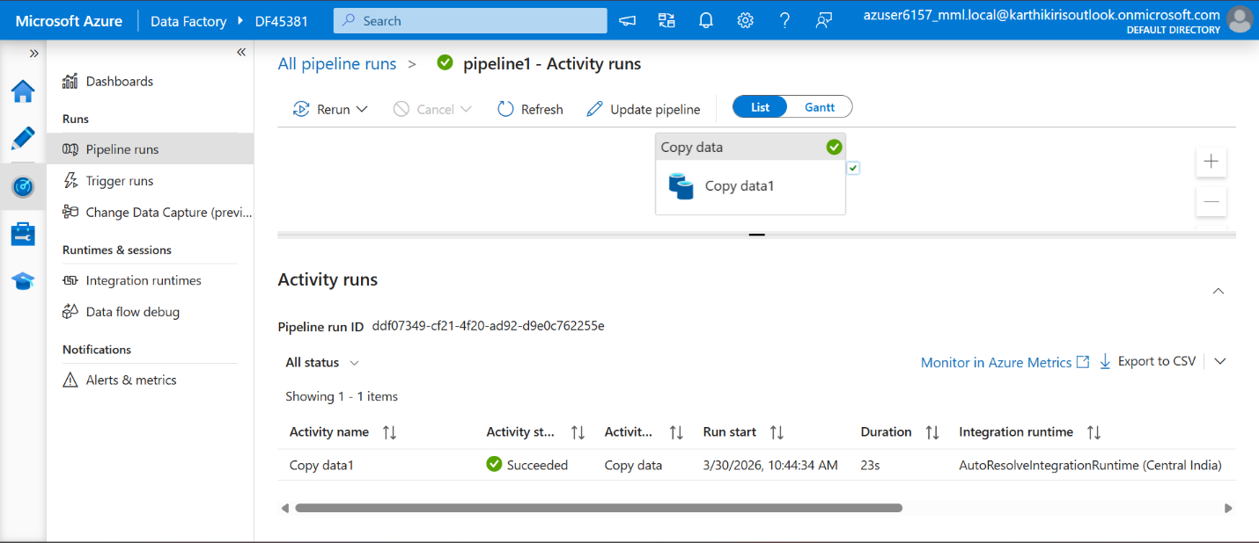

- Check output in storage->container
